System Design Specification (SDS)

Project Name: Retail Order & Inventory Management System
Version: v0.1
Author : Rushik Dumpala
Date : 11-02-2026
Status: Draft

1. TECH STACK

Component | Specification | Rationale for Selection
Frontend | React | Selected for its component architecture, strong community, and efficient DOM manipulation, perfect for a complex, dynamic order and inventory management UI.
Backend | Node.js with Express.js | Its non-blocking, event-driven architecture ensures high performance and scalability for simultaneous order and inventory updates. Express.js provides a robust framework for the RESTful API.
Database | PostgreSQL | Selected for reliability, ACID compliance, strong complex query support, and suitability for structured relational data (inventory, customer info, orders).
APIs | RESTful API | A standard, stateless architectural style that separates client and server, boosting scalability and facilitating easy integration with future third-party systems or mobile clients.
Development tools | Docker | Containerization ensures consistency across environments and simplifies application setup and deployment.
Load balancer | Nginx | Chosen for its high performance as a reverse proxy and load balancer. It will efficiently distribute incoming application traffic across multiple backend Node.js instances for maximum throughput and reliability.
Queue | RabbitMQ | Selected as a robust message broker for asynchronous tasks (e.g., order confirmations, low-stock alerts) to decouple components and boost system responsiveness.
Infrastructure | On-premise | Initial deployment will use existing on-premise hardware to maintain security and data location control, adhering to current infrastructure policy.

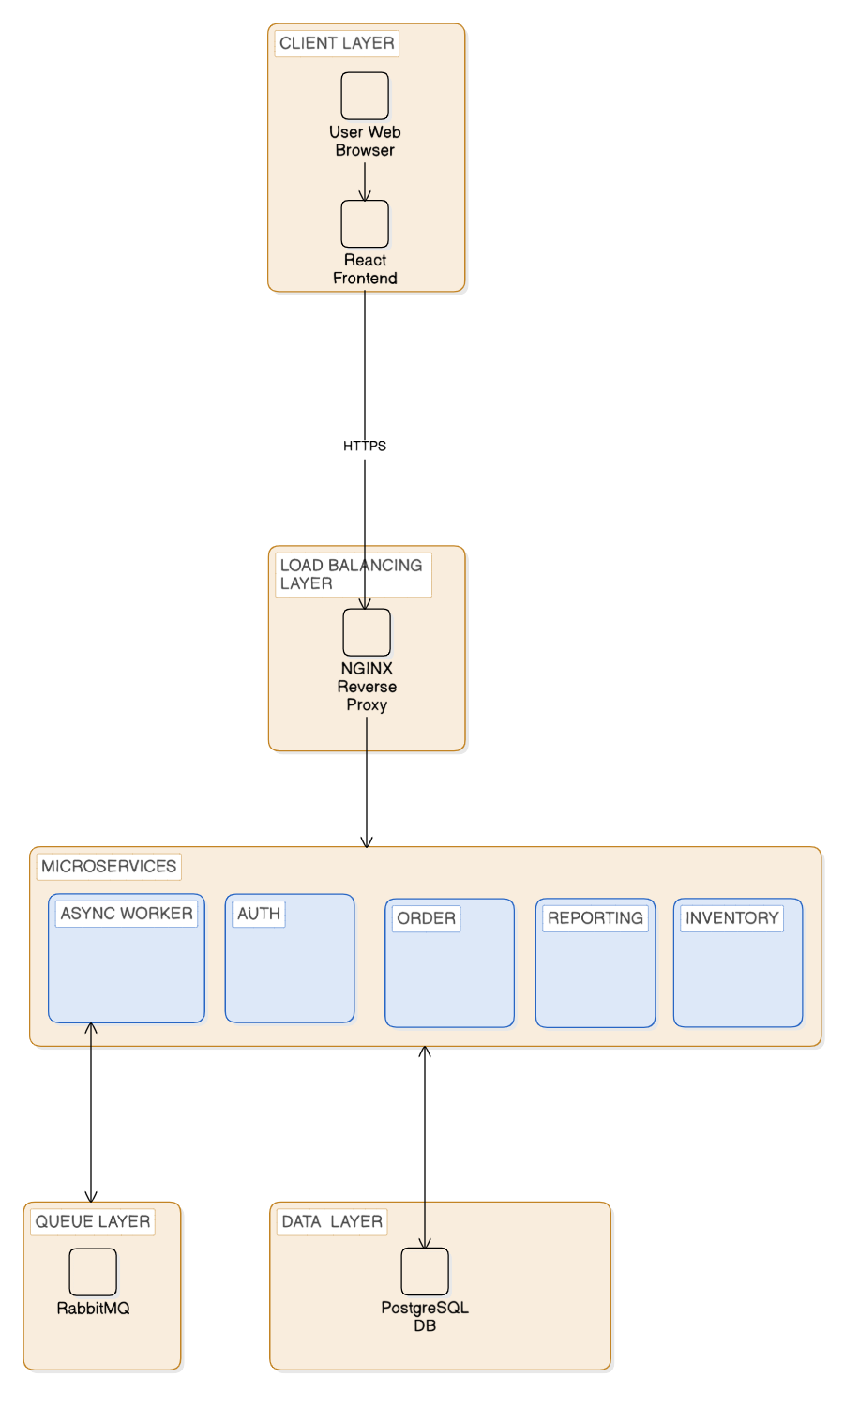
2. SYSTEM ARCHITECTURE

